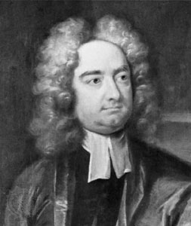Jonathan Swift
Swift's greatest gift was irony, for which he is the acknowledged master among writers in the English language. Swift employed irony for the comic purpose of correcting the general follies of society and for the polemical purpose of influencing the policies of government both in England and in Ireland. Swift also had a penchant for the repulsive and the scatological. Scatology refers to words and images having to do with excrement. The fierce disgust of Swift's scatological poems suggests that he hated filthiness and squalor above almost all other human failings. There is also in Swift's later works a tone of bitter disillusionment that suggests he expected human beings to behave much better than they were generally capable of behaving. The Neoclassical Era is sometimes called the Enlightenment or the Age of Reason because many well educated persons believed that the advance of knowledge which had begun with the Renaissance would engage the faculty of reason in the mass of humanity and turn them into lovers of peace and virtue. As we will see, Swift's masterpiece, Gulliver's Travels, debunks this expectation with scathing irony. Yet Swift also possessed deep sympathy for the poor and ordinary among humanity and became revered by the disenfranchised Irish Catholics for his attempts to influence an often exploitative English policy in their behalf. It must be remembered, too, that as an Anglican clergyman, Swift ministered to the spiritual needs of a congregation in the Irish cathedral where he was dean. Swift's sermons, preached to ordinary people, were simple, sincere statements of Christian doctrine totally devoid of irony and disillusionment.

“A Modest Proposal”

- Examine how this proposal employs elements of reason and logic, traits admired by the Neoclassicists. Does this reason “turn them into lovers of peace and virtue”?

- In what sense is the proposal “modest”?

- Examine specific arguments in the proposal that are ironic. What is the tone of this irony? Is it for a “comic purpose” as stated above?

- Apply the strategy of satire by creating a proposal to remedy a modern social problem.
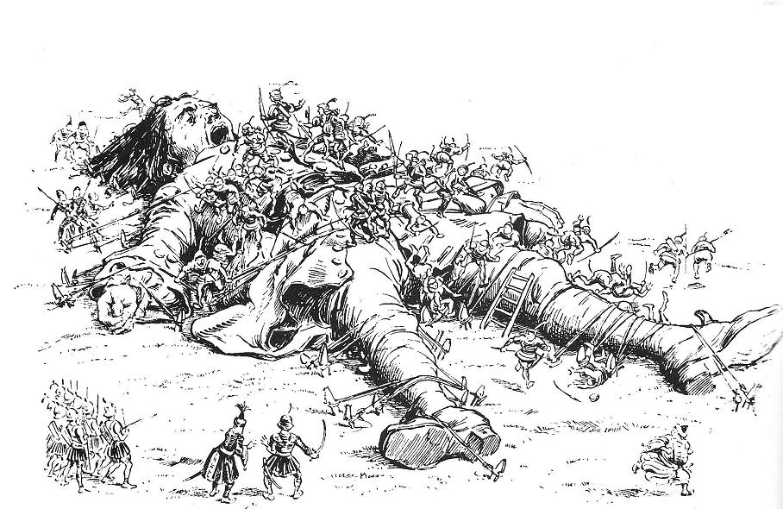
Discussion Questions: Gulliver’s Travels, Book I: “A Voyage to Lilliput”

Swift often used a form well known to his audience as a forum to present his satire. In “A Modest Proposal’ he followed exactly the rhetorical form reserved for formal essays. In a similar fashion, Gulliver’s Travels follows a popular form of literature of Swift’s day, the “travel narrative.” Because his was an age of exploration and fantastic voyages to new lands, audiences enjoyed reading about the wonderful voyages undertaken by explorers. Swift uses the conventions associated with this particular literature as a framework for all of Gulliver’s Travels.
On the specific level in Book I, most commentators agree that Swift is using Gulliver as a composite figure of three Tories: Swift himself, Robert Harley, and Viscount Bolingbroke. Harley and Bolingbroke served in the last ministry of Queen Anne as members of the Tory party. Swift shifted from the Whig party to the Tories not long after the Whigs gained the upper hand in the political struggles (he was slighted by the Whigs in several important political appointments.)

1. Explore how this narrative is an allegory. Choose a couple of aspects in the narrative that satirically point out the vices of England and human nature.

2. Analyze the qualities of Lemuel Gulliver. How does his perspective affect our interpretation of the narrative? Is Gulliver a reliable narrator?

3. What is the image of women in the text? Can we apply an autobiographical reading of Swift’s own ambivalence of women?

4. Examine the many references to scatological topics (excrement, urinating, Master Bates, etc). What is the purpose and meaning behind calling attention to all these messy details?

5. Explore all the references to observing, seeing, spectacles, and telescopes. What is Swift calling attention to?

6. Can we see Gulliver’s Travels as a classic example of Joseph Campbell’s Heroes Journey?

7. How does the narrative satirize all things Neoclassical? Can we categorize Gulliver’s Travels as a Neoclassical text if it is poking fun at its characteristics?

8. According to Thomas Hobbes:
In such condition, there is no place for industry; because the fruit thereof is uncertain: and consequently no culture of the earth; no navigation, nor use of the commodities that may be imported by sea; no commodious building; no instruments of moving, and removing, such things as require much force; no knowledge of the face of the earth; no account of time; no arts; no letters; no society; and which is worst of all, continual fear, and danger of violent death; and the life of man, solitary, poor, nasty, brutish, and short.
— Leviathan XIII (1651) "Chapter XIII.: Of the Natural Condition of Mankind As Concerning Their Felicity, and Misery.", Leviathan
Does Part I of Gulliver’s Travels agree that “life of man, solitary, poor, nasty, brutish, and short”?

